Algorithm for file updates in Python

Project description
For this project, I created an algorithm for a Healthcare company to update IP Addresses that are allowed access to restricted content. I was provided an Allowed IP address list, as well as a list of IP addresses to remove. Step by step I built an algorithm to compare the elements from the 2 lists and remove the ones that are no longer needed.

Open the file that contains the allow list
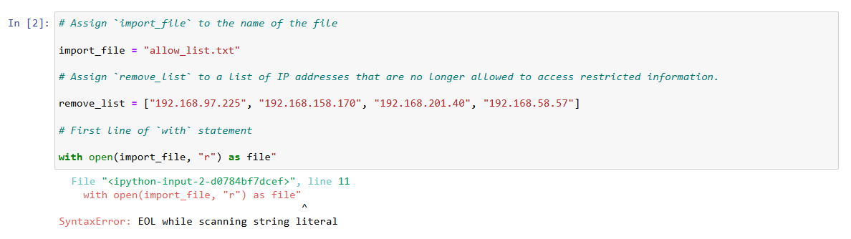

Read the file contents
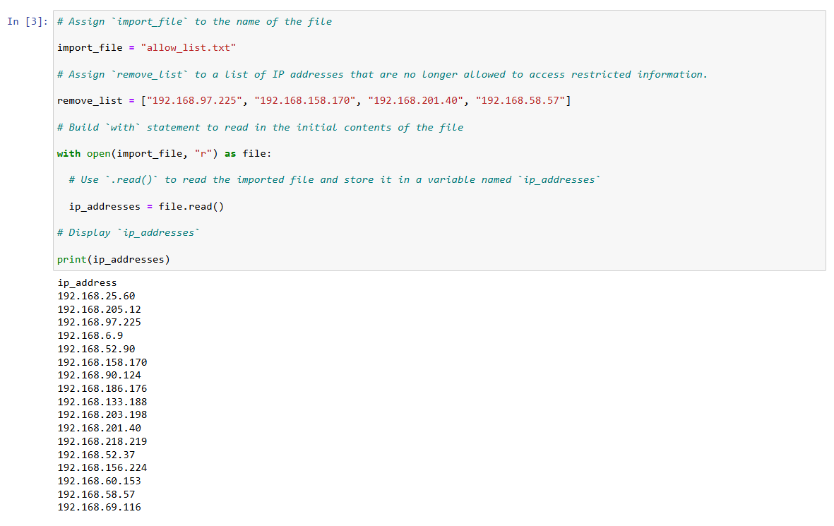

Convert the string into a list
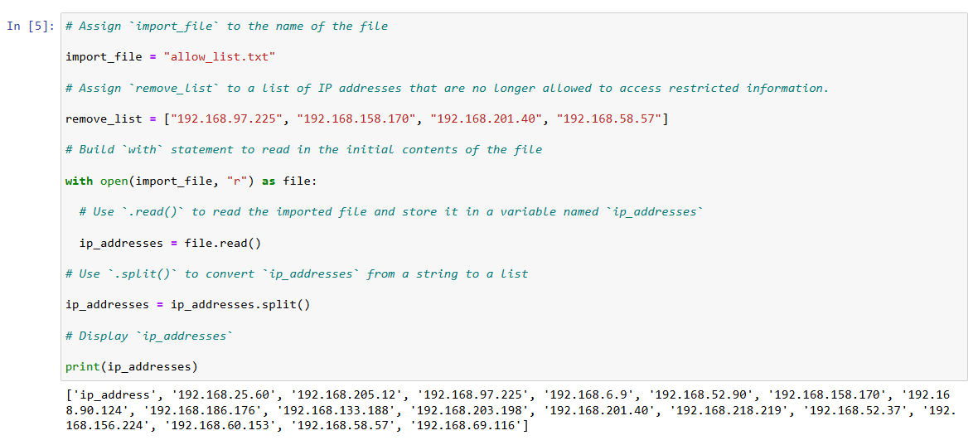

Iterate through the remove list
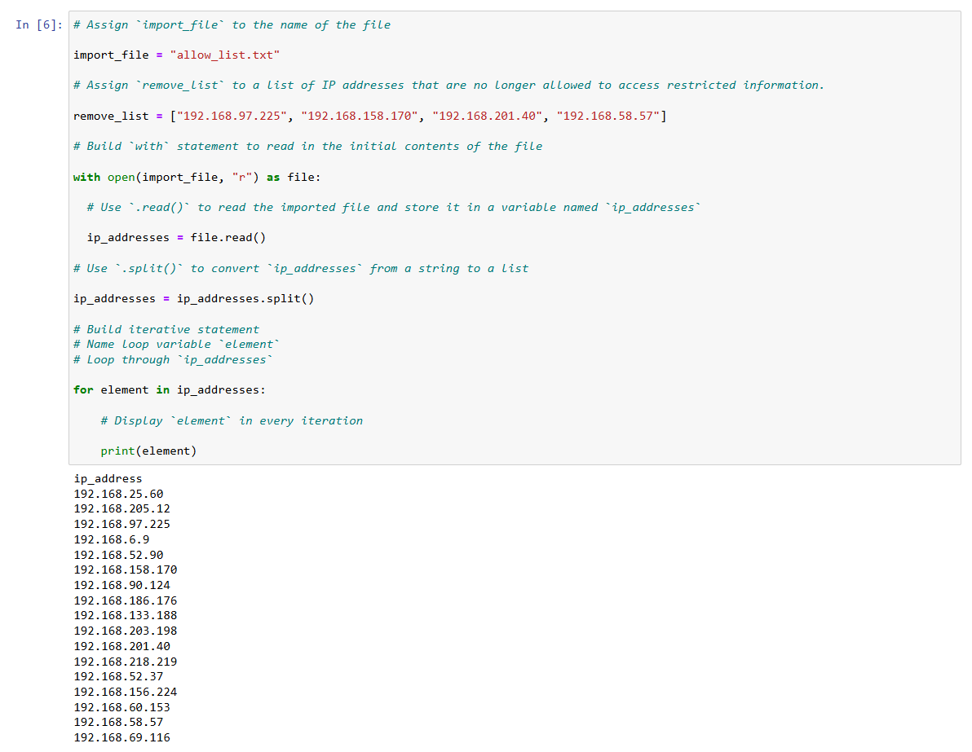

Remove IP addresses that are on the remove list
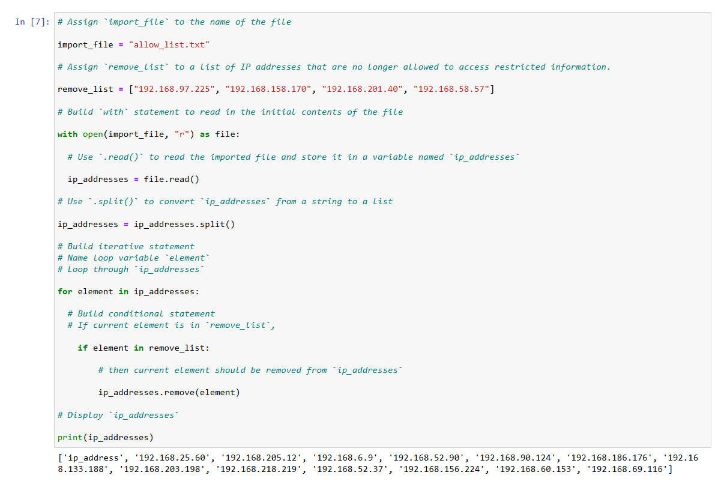

Update the file with the revised list of IP addresses
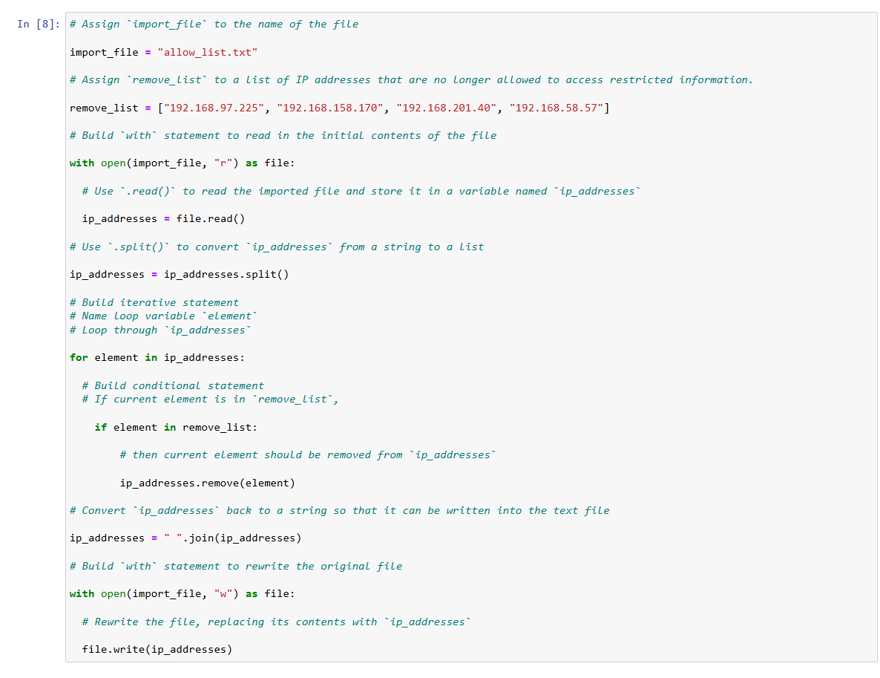

Summary
In order to build the algorithm, I first had to import, open, and read the file so I would know what I was working with. I then converted the string of IPs into a list using ,split(), and built a loop to iterate through each one. I then built an algorithm that went through the IPs and removed the ones on the remove list file using the .remove(). Finally, I updated the file by overwriting the allowed list with the IP addresses that are needed, using the .write() function, and the .read() function in order to verify my work.

